Name: Mohammad Zulhasnan bin Mohd Zahir

Matrix no.: 277834

Exercise 1: Create a class and define the instances

Example 1: The class is Smartphone

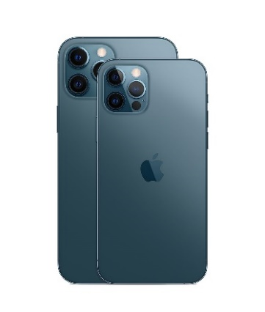

|  |
| --- |
| Smartphone |
| -Brand  -Color  -Operating System (OS) |
| -Call  -SMS  -Take photo  -Run application |

|  |
| --- |
| Smartphone1 |
| -Brand = Apple  -Color = Pacific Blue  -Operating System (OS) = IOS |

|  |
| --- |
| Smartphone2 |
| -Brand = Xiaomi  -Color = Grey  -Operating System (OS) = Android |

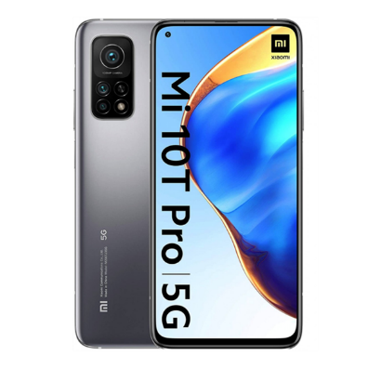

Example 2: The Class is Cat

|  |
| --- |
| Cat |
| -Cat Types  -Color  -Nation of origin |
| -Walk  -Sleep  -Run  -Eat |

|  |
| --- |
| Cat1 |
| -Cat Types = British Short Hair  -Color = Grey  -Nation of origin = Great Britain |



|  |
| --- |
| Cat1 |
| -Cat Types = Persian  -Color = White  -Nation of origin = Iran |



Example 3: The Class is Shoes

|  |
| --- |
| Shoes |
| -Shoes Type  -Colour  -Brand |
| -Protect Feet  -Style |

|  |
| --- |
| Shoes1 |
| -Shoes Type = Casual  -Color = Black and Whie  -Brand = Converse |

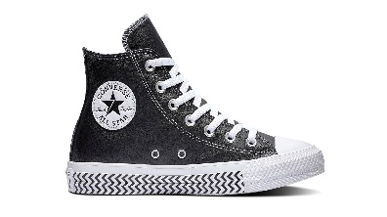

|  |
| --- |
| Shoes2 |
| -Shoes Type = Formal  -Color = Brown  -Brand = Polo |

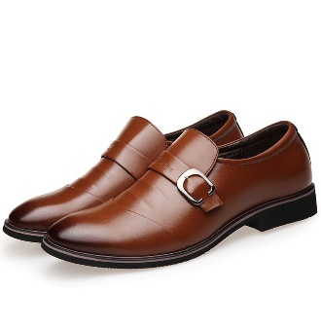

Example 4: The Class is Plane

|  |
| --- |
| Plane |
| -Plane Type  -Model  -Passanger Capacity |
| -Accelerate  -Fly  -Coordinate |

|  |
| --- |
| Plane1 |
| -Plane Type = Mid-Size Passenger Jets  -Model = Airbus 350-1000  -Passanger Capacity = 853 |

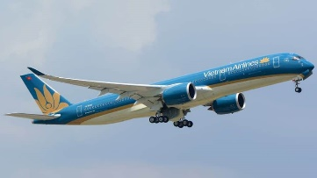

|  |
| --- |
| Plane2 |
| -Plane Type= Light Passenger Jets  -Model= Embraer 175  -Passanger Capacity = 60-100 |

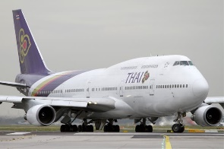

|  |
| --- |
| Motorcycle1 |
| -Brand = Yamaha  -Model = Yamaha 150zr  -Cubic Capacity(cc) = 150cc |

Example 5: The Class is Motorcycle

|  |
| --- |
| Motorcycle |
| -Brand  -Model  -Cubic Capacity(cc) |
| -Accelerate  -Break |

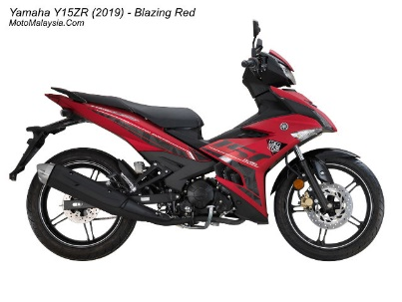

|  |
| --- |
| Motorcycle2 |
| -Brand = Honda  -Model = Honda Rs 150  -Cubic Capacity(cc) = 150cc |

